NEWS RELEASE
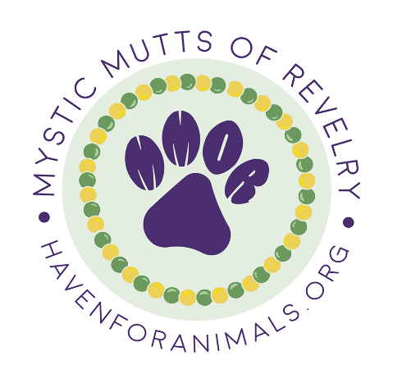
For Immediate Release
January 7th, 2022
News contact: Shannon Hesse
205.305.7200

Fairhope, AL – The 19th annual Mystic Mutts of Revelry parade benefiting The Haven for Animals, Fairhope’s No-Kill Animal Shelter, will be held on February 19th. The walking parade begins and ends at Fairhoper’s park in downtown Fairhope.
This year’s theme is “Pawjama Party.” Both human and their pets are encouraged to wear “pajama’s” to the event.
Led by emcee and Grand Marshall, Rose Ann Haven, the parade will begin at 1:00pm from the park located on the corner of S. Church Street and Morphy Avenue.
For complete event details including the downtown parade route and pre-registration link, visit our Facebook page at https://www.facebook.com/mysticmuttsofrevelry .
All pets and their human registered before February 5th will be eligible for the drawing that will determine which mutt will be King and which will be Queen for a day. Extra drawing chances may be purchased on the registration page.
Comfort Colors t-shirts with the MMOR logo will be available for purchase on the registration page and on parade day.
Parade passes are $20 per mutt and $15 per human over age 12, $10 for 2 – 12 and free under 2.
Registration and family-friendly festivities will begin at 12:00 pm on parade day in Fairhoper’s Community Park.
Thank you to the 2022 MMOR Presenting Sponsor, McSherry’s Irish Pub.

Proceeds from the parade provide vet care, vaccinations, medicine, food and much more for homeless animals.

##

